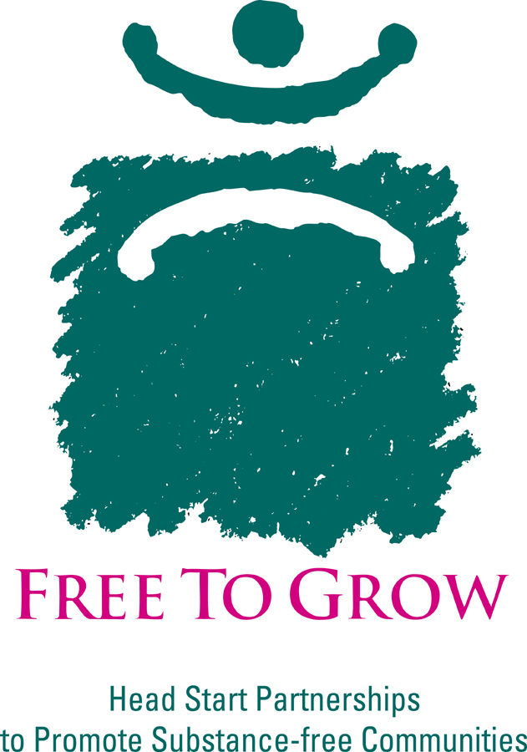
IDENTIFYING ALCOHOL AND OTHER DRUG ABUSE

The majority of people in the U.S. do not use illegal drugs and drink alcohol moderately (one or two drinks per occasion once or twice per month) or not at all. Still, a significant percentage of people (10% or less) experience substance abuse or dependence with alcohol, illegal drugs, or prescription medication. An additional 10-20% of the population at any given time may be putting themselves at risk with occasional overdrinking or, less commonly, with misuse of other drugs (e.g., marijuana, cocaine, methamphetamines, etc.). Substance use tends to be most prevalent among men and among people in the 18-24 age range, although problems can occur throughout the lifespan. External conditions such as community environment, poverty, and availability may have an impact on individual risk. Substance abuse is treatable, although the majority of people in the U.S. still resolve their problems without formal treatment.

Substance abuse is defined in general terms as recurrent use of a substance over a 12-month period in spite of physical, legal, work-related, interpersonal, or family problems.

Substance dependence adds the elements of loss of control over amounts used, difficulty stopping use once begun, increased tolerance to the substance (it takes more of the alcohol or other drug to feel the effects), withdrawal symptoms when use is stopped, and an increased focus on obtaining, consuming, and recovering from the effects of the substance use.

Risky or hazardous use might be defined as incidents of substance misuse that put people at increased risk for negative consequences (physical, legal, interpersonal, etc.), but don’t meet all of the conditions of substance abuse or dependence.
How much is too much? For illegal drugs (including misused prescription medication), any use might be considered too much in that the society at large does not condone the use, and users face legal consequences. This is true for underage alcohol use as well, although to a lesser degree. What is a safe level of drinking? For most adults, moderate alcohol use--up to two drinks per day for men and one drink per day for women and older people--causes few if any problems. Daily drinking can cause increased risk, however, as can increased quantities consumed on one occasion (5 or more drinks for men; 4 or more drinks for women). (Note: One drink equals one 12-ounce bottle of beer or wine cooler, one 5-ounce glass of wine, or 1.5 ounces of 80-proof distilled spirits.)
Certain people should not drink at all, however:
- Women who are pregnant or trying to become pregnant
- People who plan to drive or engage in other activities that require alertness and skill (such as using high-speed machinery)
- People taking over-the-counter or prescription medications that can interact with alcohol.
- People with medical conditions that can be made worse by drinking
- Recovering alcoholics and individuals of any age who cannot restrict their drinking to moderate levels.
- People younger than age 21. (Source: NIAAA and USDA Dietary Guidelines, 5th edition, 2000).

SIGNS TO LOOK FOR: SUBSTANCE ABUSE

Physical signs and symptoms of substance abuse will vary depending upon the drug being used, but there are common indicators you may encounter. Keep in mind that physical illness and other mental health problems may produce some of the same indicators or occur along with a substance abuse problem. Not all of the signs will be present and may not be obvious in some cases.

- Secrecy or avoiding contact; difficult to engage; not answering the door when home
- Missed appointments or absenteeism from work or school
- Declines in work performance or in children’s school performance
- Messy or disorganized home environment
- Legal difficulties
- Changed behaviors with regard to socializing, childcare, or schedules (e.g., frequently sleeping in)
- Complaints from neighbors or housing authorities about parties, excessive noise
- Increased isolation from family and friends
- Mood swings; outbursts of anger, paranoia, or defensiveness
- Financial difficulties not otherwise explained
- Evidence of accidents, falls, and frequent illness including sinus problems
- Physical evidence of alcohol or drug use (empty bottles, drug paraphernalia such as syringes, cigarette rolling paper, pipes or “bongs”, etc.)
- Change in sleep patterns, appetite, or mood
- Dilated or constricted pupils; lapses of concentration; lethargy or excessive drowsiness (“nodding off”); slurred speech (alcohol or depressants); excessive excitability or rapid speech (stimulants); memory lapses or “blackouts”, i.e, not being able to remember all or part of an evening when intoxicated (alcohol)
- Care-taking behavior by children in the home (e.g., with parents, younger siblings, household chores, etc.)

Asking the right questions:
Questions about substance use are part of any family assessment and should be asked in a routine manner (see “Raising the Issue” below). If family members are willing to respond, basic questions could include:
- What substances are being used?
- How recently, how much, and how often are the substances used?
- What happens when the person uses? Are there negative consequences? Does the person feel guilt or remorse?
- Why does the person say they use the substance? (Using to deal with negative feelings or situations tends to be higher risk.)
- Has the person ever thought they had a problem with alcohol or other drugs?
- Has the individual ever stopped using or tried to stop using? If so, why?

Consider integrating a brief screening tool for alcohol problems into your family assessment. A recent example being used by one FTG site is the RAPS4Q-F (Rapid Alcohol Problem Screen Quantity/Frequency) (Cherpitel, 2002):

The RAPS4-QF Questions
- During the last year have you had a feeling of guilt or remorse after drinking? (Remorse)
- During the last year has a friend or family member ever told you about things you said or did while you were drinking that you could not remember? (Amnesia/Blackouts)
- During the last year have you failed to do what was normally expected from you because of drinking? (Performance)
- Do you sometimes take a drink in the morning when you first get up? (Starter/eye-opener)
- During the last year have you had five or more drinks (four or more for women) on at least one occasion? (Quantity)
- During the last year did you drink as often as once a month? (Frequency)
Positive screen if one “yes” answer on any of the first 4 questions, or “yes” on both of the last 2 questions (Quantity/Frequency).

